Our Lady and St Patrick Primary School
Bunscoil Mhuire agus Phádraig
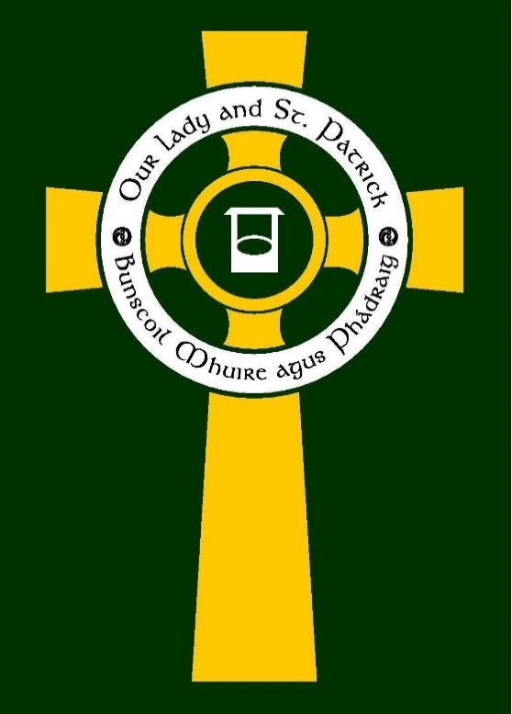

Date of review: March 2025
Date of renewal: March 2028

Signed off by: ___ ____ ________
Board of Governors

Menstrual Wellbeing and Period Dignity Policy

The Hand of God at Work
Lámh Dé Ar Obair

- Contextual Information

What is Period Dignity?
Period dignity refers to the accessibility and availability of essential care needed to support a female’s period, in conjunction with the removal/breaking of stigma and taboo around periods.
Education is a key factor in breaking the stigma surrounding periods and promoting respect, understanding and open discussions about what people may experience when menstruating.
Importance of Period Dignity:
The Period Dignity Policy will ensure that access to free products can:
- Promote equality
- Help keep young people in school
- Increase concentration in class through not having to worry about lack of period products
- Support good health
- Increase confidence in participating in extracurricular activities

- Aims of a Period Dignity Policy:
Through the implementation of a respectful approach to Period Dignity and Menstrual Wellbeing in Our Lady and St Patrick PS Bunscoil Mhuire agus Pádraig we aim to:

- Ensure that pupils, staff and parents/carers understand the term ‘Period Dignity’ and ‘Period Products’
- Promote period dignity in school and ensure that everyone within the school community has access to period products;
- Ensure that all pupils, staff and parents/guardians understand the impact of periods on the emotional, mental, social and educational well-being of pupils;
- Enable learners to achieve their potential by reducing any barriers they may experience due to periods;
- Reduce stigma/taboo in relation to periods by providing all pupils with relevant, age-appropriate information on periods;
- Enable learners to understand how to deal with period issues, hygiene and disposal of period products;
- Promote respect, understanding and open discussion about what people may experience when menstruating; and
- Have a positive impact on pupil confidence, well-being, attendance and attainment.

- Policy Formation
At Our Lady and St Patrick PS Bunscoil Mhuire agus Pádraig we aim to raise awareness of Period Dignity through the formation of the policy. The policy was drawn up in line with EA guidelines and will take on board the opinion of stakeholders prior to ratification. Following an analysis of the responses, conclusions were shared with all product users. This involved:
- Informing pupils about Period Dignity (P6/7 only)
- Inform staff/ visitors about Period Dignity
- Inform parents about Period Dignity
- Ensure all members of the school community can access period products
- Ensure all members of the school community are aware of the Period Dignity’s key contacts

- Key staff and responsibility for Period Dignity:
A Relationships and Sexual Education (Flourish) Programme will be delivered to all children throughout the school therefore all members of the school community will be aware of Period Dignity.
- School Leader with responsibility: Mrs K. Madine (Deputy Designated Teacher for C.P and Pastoral Lead)
- School Governor with responsibility: Mrs M Woodward

- Whole School Approach to Period Dignity
Period Dignity and Menstrual Wellbeing Education:
The teaching of Period Dignity/ Menstrual Wellbeing will support the ethos of the school and reflect the religious principles held by the school community. Period Dignity education will be linked with the delivery of Relationships Sexual Education (Flourish). It will also be firmly embedded in the PDMU Curriculum as it is concerned with and integral to the physical, spiritual, emotional, moral, social and intellectual development of pupils. The teaching of Period Dignity/ Menstrual Wellbeing will be inclusive of all children including gender, culture and SEN.

Where possible and appropriate, Period Dignity Education will be delivered in mixed-gender classes to increase understanding among all pupils and challenge/reduce stigma, myths and stereotypes. External organisations/agencies such as Love For Life will be utilised to complement the delivery of elements of the RSE curriculum/Period Dignity and Menstrual Wellbeing.
The management and co-ordination of Period Dignity/ Menstrual Wellbeing Education within the school will be led by Mrs Madine and Mr Robinson and they will ensure training is disseminated to all school members and resources are regularly reviewed and updated.

- The Period Dignity Scheme
- Early consultation was carried out with pupils, parents, staff and visitors on the Period Dignity Scheme.
- Responses to the consultation were analysed and information on product types and location was shared with all product users through the sharing of a Statement of Arrangements.
- Products will be stored with the Period Dignity lead and Mrs C. Fitzpatrick and will be monitored (including checking expiry dates) and supplies will be replenished on a regular basis.

Policy Implementation date:
Policy Renewal date:
Policy reviewed and approved by:

Appendices

Our Lady and St Patrick PS Bunscoil Mhuire agus Pádraig Period Dignity Programme

The Period Products (Department of Education Specified Public Services Bodies) Regulations (NI) 2024

Statement on Arrangements for the Provision of Free Period Products

Details of Specified Public Service Body

Name of Specified Public Service Body | Our Lady and St Patrick PS Bunscoil Mhuire agus Pádraig
Main Address of Specified Public Service Body | Edward Street Downpatrick, Bt306JD

Publication Details

Date of first publication
Date of subsequent publication
Where will this statement be published? | - School Website  - Staff email  - Parent email

Details of Consultation carried out
When was the consultation carried out? | Friday 27th March – Tuesday 1st April.
Who was consulted? | - Boards of Governors  - Parents  - Staff  - Children in P6/7  - Outside service providers who regularly use school building
How did the consultation process establish? | The Vice Principal and Period Dignity Lead drafted a form to share with Product users. The Google Form was shared with all Product users to gain insight into which products should be made available and the location in the premises in which the products should be made available.  There was the option of anonymity on the form which provided privacy and confidentiality to the product users. The options provided for the locations of the product and articles of use reflected the care and dignity we hold for all users.

The arrangements
What arrangement have been put in place as a result of the consultation? | As well as products being always available, the Act requires that period products are obtainable reasonably easily, in a location that they have chosen and in a way that respects dignity, privacy and confidentiality. It requires a reasonable choice of period products be made available, having regard to articles which are reusable.  Analysis of the consultation:  The school will provide each of the options outlined on the survey and locate these in classes, the office, staff and girls bathroom.
How will information be publicised and shared with Product users? | At regular intervals the policy lead will notify product users in small groups. Class teachers will also make product users aware as and when required.

Outside Support for the Delivery of Period Dignity
https://www.loveforlife.org.uk/
https://ccea.org.uk/learning-resources/period-dignity
www.education-ni.gov.uk
https://www.education-ni.gov.uk/articles/pilot-scheme-address-period-dignity-schools

