Our Lady and St Patrick Primary School
Bunscoil Mhuire agus Phádraig


Date of review: November 2025
Date of renewal: November 2027

Signed off by: ___ ____ ________
Board of Governors

Fire Safety Policy

The Hand of God at Work
Lámh Dé Ar Obair

Contents
- Introduction

- Aims

- Legal Framework

- Roles and Responsibilities

- Risk Assessment

- Preventative Measures

- Fire Drills

- Procedures in the event of a fire

- Personal Escape and Evacuation Plans

- Equipment

- Monitoring and Review

Introduction
Our Lady and Saint Patrick, Bunscoil Mhuire agus Phádraig is committed to protecting and preserving the health and safety of all our pupils, staff and visitors – this includes our dedication to mitigating the risk of fires. We will achieve this by training our staff, educating our pupils and ensuring the school’s fire safety measures are checked regularly and in full working order. The school will maintain an EA Fire Safety Logbook and record all checks, drills, and maintenance in line with EA guidance. Fire drills will be conducted once per term and recorded in the EA Fire Safety Log.In the event that a fire breaks out, we have put in place procedures to ensure all risk is minimised and the premises can be evacuated quickly.

Aims
It is the overall aim of Our Lady and Saint Patrick, Bunscoil Mhuire agus Phádraig, to minimise the risks to children, staff, and visitors which may arise from fire. This will be achieved by working together to ensure precautions are taken to avoid fires occurring and by ensuring that procedures for minimising the effects of an outbreak of fire and evacuating the premises are in place.
The aim of this policy is to ensure the safety of all of our staff, pupils and members of the public in the immediate vicinity of the school, which may arise from fire. This will be achieved by conducting, recording and acting upon regular fire risk assessments, ensuring suitable precautions are taken to avoid fires occurring and by ensuring that procedures for minimising the effects of an outbreak of fire and evacuating the premises in an emergency are in place.

Legal Framework
At Our Lady and Saint Patrick Primary School, Bunscoil Mhuire agus Phádraig, it is our duty to take all necessary steps, as far as is reasonably practicable, to ensure the safety of all pupils, staff, volunteers and visitors in the school from the dangers of fire.
This policy aligns with Education Authority Northern Ireland Fire Safety Guidance for Schools and will be implemented using EA templates, logbooks, and training requirements.
The following gives a brief outline of the legal requirements we adhere to:
The Fire and Rescue Services (Northern Ireland) Order 2006
This sets out the core legal duties of the “appropriate person” (E.g the schools employer or premises manager) to ensure fire safety, including carrying out a proper Fire Risk Assessment
The Fire Safety Regulations (Northern Ireland) 2010
These regulations impose practical obligations such as:
- Installing and maintaining fire detection systems, firefighting equipment and emergency lighting/signage
- Maintaining clear emergency exit routes
- Ensuring all systems are kept in efficient working order and good repair
Education Authority Guidance and Training
- The Education Authority (EA) oversees implementation in schools, requiring annual Premises Fire Management Team Training and offering an array of templates and tools – like evacuation plans, fire safety logs, and risk assessment templates – specific to educational premises.
Health & Safety at Work (Northern Ireland) Order 1978
This foundational order provides a broader duty to ensure health and safety in workplaces, including schools.
Managing Health and Safety in Schools (Department of Education Guidance)
Requires schools to have a health and safety management system which includes conducting risk assessments and regularly reviewing safety policies.

Roles and Responsibilities
Board of Governors
The governing board, in consultation with the headteacher, will:
- Ensure personal and whole-school familiarity with the requirements of the appropriate legislation and codes of practice.
- Create and monitor a management structure responsible for health and safety in the school, including, but not limited to, fire safety.
- Help to put in place measures to identify risks relating to possible accidents and injuries, suggesting reasonable adjustments to prevent them occurring.
- Ensure there is the following in place:
- A safe place for all users of the site, including staff, pupils and visitors.
- Safe means of entry and exit for all site users.
- Equipment, grounds and systems of work which are safe.
- Safe arrangements for the handling, storage and transportation of any articles and substances.
- Safe and healthy working conditions that comply with statutory requirements, codes of practice and guidance.
- Supervision, training and instruction, so that all staff can perform their duties in a healthy and safe manner.
- Protective equipment and clothing, where necessary, alongside any necessary guidance and instruction.
- Adequate funds to ensure the training of the fire safety officer and all other staff.

Principal (Designated Fire Safety Officer)
As Designated Fire Safety Officer, the principal will:
- Take responsibility for the school’s fire safety matters
- Oversee the day-to-day development and implementation of safe working practices and conditions for all staff, pupils and visitors.
- Take reasonably practicable steps to ensure this policy is implemented by all members of staff across the school.
- Take steps to ensure all members of staff, pupils and visitors are familiar with this policy.
- Identify risks relating to possible accidents and injuries and make reasonable adjustments and suggestions to prevent them occurring.
- Coordinate the implementation of all fire safety measures, ensure staff and pupil training takes place, and monitor the standard of the school’s fire detection and protection equipment.
- At least once per term, undertake a whole-school fire evacuation drill.
- Review relevant and updated legislation to ensure the school is working within the parameters of the law and government guidance.
- Ensure new and existing staff members undertake training sessions at least once per year, in line with the school’s Fire Safety Training Plan.
- Communicate relevant correspondence regarding fire safety to all members of staff and, where necessary, the governing board.
- Review and update where necessary the school’s Fire Safety Training Plan and other relevant procedures once per year.
- Conduct risk assessments and ensure necessary procedures are in place to mitigate the risks of fires.
- Draw up a plan of the school, including the locations of all fire extinguishers, hosepipes and fire exits.
- Create an individual Personal Emergency Evacuation Plan (PEEP) for each person who will require assistance during fire drills.
- Work with the principal to nominate a temporary fire safety officer in their absence.
- Take steps to ensure the appropriate precautions, including the communication of this policy, are put in place where events are organised outside of normal school hours, or by third party organisations.
- Review activities to ensure specific restrictions on events, such as setting capacities and limiting the types of activity
Staff Members
Staff members will:
- Cooperate with their colleagues and principal on all fire safety matters.
- Carry out their work in accordance with fire safety training and instructions.
- Inform the fire safety officer of any work situation representing serious and immediate danger, so that remedial action can be taken.
- Familiarise themselves with all their responsibilities as set out in this policy, and aspects of their work relating to potential fire hazards.
- Avoid any conduct which puts themselves or others at risk.
- Follow, and help to carry out, relevant risk assessments to ensure the safety of themselves and other staff members, pupils and visitors.
- Ensure that all staff, pupils and visitors are applying fire safety regulations and adhering to all rules, routines and procedures in place.
- Ensure all equipment is in good working order and safe to use, including adequate fire safety guards.
- Use the correct equipment and tools for their work and any protective clothing supplied.
- Ensure any toxic, hazardous or flammable substances are used correctly, and stored and labelled as appropriate.
- Report any defects in equipment or facilities to the designated fire safety officer.
- Exercise good standards of housekeeping and cleanliness.
Pupils
All pupils will:
- Ensure they are aware of the school’s fire safety procedures, with support from the school.
- Exercise personal responsibility for the health and safety of themselves and others.
- Respond to the instruction given by staff members in an emergency, e.g. evacuation procedures.
- Not misuse, neglect or interfere with items supplied for their, and other pupils’ health and safety.
- Report any defects in equipment or facilities to their teacher as soon as possible.
Visitors
All visitors will:
- Familiarise themselves with all health and safety policies and procedures including, but not limited to, this policy.
- Be aware of the school’s evacuation procedure and fire assembly points.
- Respond to the instruction given by staff members in an emergency.
- Put a principal person in charge, who will take responsibility for safe practice, in the event the school is used for purposes not under the direction of the headteacher, e.g. building works.
- Inform the principal of all potential risks to staff, pupils and visitors.
- Assist the school in carrying out relevant risk assessments before any work is carried out.
- Raise any concerns regarding fire safety with the principal (Fire Safety Officer).
- All contractors will receive a fire safety induction and sign the EA Contractor Compliance Form before commencing work
Staff Training
Appropriate specific training for the school principal (Fire Safety Officer) will be undertaken at least every three years.
Every member of staff will receive instructions in fire precaution during induction. Students and visitors will be instructed at the beginning of their attendance. All members of staff will receive annual fire safety refresher training. Designated Fire Wardens will receive enhanced training as per EA requirements.
This will include:
- Understanding the Emergency Plan/fire procedure
- The importance of fire doors
- The significant findings of the Fire Risk Assessment
- Guidance on the use of relevant fire fighting equipment eg fire extinguishers, fire blankets – to protect escape route
- Reporting to the assembly area
- Exit routes including alternatives
- General matters of fire safety eg keeping combustibles away from possible ignition sources
- Assisting visitors and any disabled persons from the building
Risk Assessment
As fire safety officer, the principal, will ensure all fire related hazards are identified and risk assessments are completed for all areas of the school, in accordance with legal requirements and Educational Authority (EA) guidance.
Risk assessments will be used to ensure that the school premises and facilities are maintained to a standard that ensures the health, safety and welfare of pupils, staff and visitors.
The school will maintain a Fire Safety Risk Assessment for all premises under its control and will include the procedures that are in place to:
- Reduce the likelihood of fire.
- Maintain fire detection and alarm systems.
- Familiarise staff and pupils with emergency evacuation procedures.
The Fire Safety Risk Assessment will be regularly reviewed and updated, particularly in circumstances where there is reason to suspect it is no longer valid or where significant changes to the premises take place.
The fire safety officer will have the appropriate qualifications and experience required to competently carry out the Fire Safety Risk Assessment.
Regular assessments of high-risk areas, such as kitchens, will be undertaken. Annual risk assessments will be conducted for all other lower-risk areas of the school.
The fire risk assessments will be reviewed by the fire safety officer and will be amended after:
- Any structural changes, e.g. alterations to the layout of the premises or refurbishment, have taken place.
- Any change to the use of the school grounds which may affect the risk rating.
- Any change to work processes or equipment which may introduce new fire hazards.
- Any change to the number of people using the school, to ensure that fire escapes and fire assembly points can accommodate the numbers safely.
All visitors and contractors will be made aware of the risk assessments relevant to their activities as soon as possible after entering the school. The fire safety officer will use checklists to ensure all fire detection and protection equipment, e.g. smoke alarms and fire extinguishers, are in working order. Checklists of all kitchen and electrical equipment, e.g. cookers and heaters, which pose a potential fire risk, will be taken to ensure they are in working order.
Preventative Measures
As fire safety officer, the principal will inspect and review the school’s fire prevention measures regularly to ensure the school is achieving maximum fire safety.
As fire safety officer, the principal will ensure that regular checks are carried out on the following:
- Fire doors
- Extinguishers
- Fire blankets
- Hose reels
- Emergency lighting
- Signage and exit routes
Fire hazards, such as hot surfaces, naked flames, electrical equipment and flammable liquids, will be identified by the fire safety officer and measures will be put in place to ensure these risks are mitigated and controlled.
Hot surfaces, such as electrical heaters, will be kept uncovered and clear at all times. All flammable materials and fuels, such as paper, cardboard and solvents, will be securely disposed of. Where possible, naked flames and radiant heaters will be replaced by fixed convector heaters or central heating systems.
Fire exit maps will be displayed prominently in all classrooms, corridors, and communal areas, as per EA guidance.
Good housekeeping
The risk of fire can be greatly reduced by a regime of good housekeeping within the workplace, and the need for good housekeeping cannot be overemphasised; if good housekeeping is not maintained, the risk of fire spreading is vastly increased.
Our Lady and Saint Patrick, Bunscoil Mhuire agus Phádraig recognises the importance of good housekeeping, including not obstructing fire routes, fire doors and general tidiness. Pupils will also be made aware of the importance of good housekeeping.
The school’s housekeeping rules include:
- No smoking anywhere within any of the school buildings.
- Spillages will be cleaned up as soon as possible.
- Rubbish will be cleared away and will not be left in fire routes or against the building fabric.
- Flammable waste and contaminated rags will be kept in separate metal bins with close fitting metal lids.
Provision and maintenance of emergency routes and exits
As part of the school’s monthly fire safety inspection, the fire safety officer will ensure that:
- All fire escape routes are clear of obstruction.
- Emergency routes and exits lead as directly as possible to a place of safety.
- Emergency routes and exits are identified by suitable fire signs.
- Emergency fire doors open in the direction of escape wherever possible and are unobstructed.
- Emergency fire doors are not locked, and can be easily and immediately opened by any person who may need to use them in an emergency.
- Emergency fire escape routes and exits are provided with emergency lighting, of adequate intensity in case of failure of their normal lighting.
- No items are stored under stairways.
All fire doors will be regularly checked by a competent person to ensure that they remain in efficient working order.
Relevant risk assessments will be conducted to ensure areas for concern are identified and addressed. Wastepaper bins are emptied daily to mitigate risks. To minimise the risk of a fire, outdoor waste containers and refuse bins will be kept at least five metres from the school building at all times.
Matches and other sources of ignition are kept in a locked store cupboard, away from pupils and can only be accessed after gaining permission from the fire safety officer. Electrical equipment will be reviewed in accordance with relevant school policy, and steps will be taken, e.g. regular checks by the fire safety officer, to ensure equipment is maintained to a high standard
Fire Drills
The Principal shall ensure the fire evacuation procedure is practiced once per term, in line with EA guidance, and recorded in the EA Fire Safety Log. Feedback will be gathered from the staff and children following the Fire Drill. The principal keeps a record of all Fire Drills.
During the fire drill, teachers will take a zero-tolerance approach to pupils misbehaving or running. Pupils will be expected to behave vigilantly, as they would in the event of a real fire.
Procedures in the event of a fire
When the Fire Alarm is raised all children and staff should evacuate the building immediately and assemble in the designated areas as per the Evacuation Procedure. Staff should use the safest and most convenient escape route bringing with them a copy of their class register. Children in transit should attach themselves to the nearest class or make their own way out of the buildings. Staff in a classroom without specific responsibility for individual children should assist their nearest class and shepherd any children in transit out of the school safely. Teaching and ancillary staff who are not in a classroom should evacuate the building immediately. Classroom assistants should return to their class, if safe to do so, to help evacuate the class. Each room has a copy of the Fire Procedure. Once at the assembly area, teachers should inform the Fire Safety officer/ Principal if they have concern about children or others who may still be in the premises.
A Fire Drill will take place once a term to ensure all staff and pupils are fully aware of the correct Emergency Evacuation Procedures.
Emergency Evacuation Procedure
In the event of a fire or a fire drill, the following procedures must be followed:
In the event of fire, the person who discovers the fire and/or smoke will sound the nearest fire alarm. As soon as the fire alarm sounds the fire brigade will be called, either automatically by the automated fire alarm system, or by the fire safety officer.
All pupils, volunteers and visitors will be advised never to fight fire; instead, they will simply sound the alarm and exit the building via the nearest route out to a safe area.
In the event of a fire or a fire drill, the building will be evacuated without delay and all pupils, staff members and visitors will proceed to the designated fire evacuation point – Front Yard
On hearing the alarm, teachers and classroom assistants must escort their class to their designated nearest exit or safest exit.
Teachers will be made aware of designated nearest exit. The principal will make any cover teacher aware of designated nearest fire exit upon induction.
The most senior staff member present will summon emergency services.
Teachers must ensure to bring a class list for register.
All personal items must be left behind.
Teachers must ensure that children exit the building in a calm and orderly manner, keeping to the left-hand side of the corridor. Teachers must ensure that children walk in a single file whilst exiting the school.
All teachers must ensure that there is an awareness of any personal escape and evacuation plan (PEEP) within their classroom and that these are followed.
In the event of a child being in the bathroom when the fire bell rings, he/she must not return to the classroom, but instead must exit the school through the nearest safest exit and rejoin the class at the designated fire evacuation point (Front Yard).
Doors and windows should be closed before exiting unless unsafe to do so.
Once at the designated fire evacuation point, teachers must take a class register and report any child / staff member missing.
The principal (or designated individual if principal is not on the premises) will be responsible for an overall head count, ensuring all staff, pupils and visitors have been accounted for.
People will only be allowed to re-enter the building once it has been deemed safe by the fire safety officer or other responsible person, e.g. member of the fire brigade. If the building is not safe to re-enter all staff members, pupils and visitors will be sent home until further notice. Pupils may be sent to another building if it is deemed fit for purpose by the fire safety officer and a trained professional, e.g. member of the fire brigade.
In the event someone is injured in the fire, the fire safety officer will ring for an ambulance immediately. Whilst waiting for the emergency services, the school’s first aider will administer any first aid required.
Measures such as multiple fire escapes and exits have been put in place to ensure all staff members, pupils and visitors can escape the school. Fire exits must be kept clear and are clearly signed. To ensure the fire alarm is heard throughout the school buildings, manual call points are fitted throughout the school.
The school has a relevant and up-to-date Evacuation Procedure in place. The Evacuation Procedure will be reviewed by the principal once per year, to ensure it is accurate and relevant. A copy of the school’s Evacuation Procedure is kept in every classroom. As part of their training, all staff members will familiarise themselves with the Evacuation Procedure. Details of the school’s fire evacuation points are available in the Evacuation Procedure.
Personal Escape and Evacuation Plans
All persons that require assistance to evacuate the building should have a written Personal Emergency Evacuation Plan (PEEP). Staff should be aware that they must endeavour to evacuate them in the event of an emergency (without putting themselves at risk), and not wholly rely on the fire and rescue service. PEEPs will be reviewed annually or whenever pupil needs change, ensuring compliance with EA inclusive practice guidance

Equipment
All areas and rooms, including offices and cupboards, within the school are fitted with a smoke detector. Larger rooms, such as the school hall, are fitted with a heat and smoke detector.
Fire detection and alarm systems will be tested each week. A competent person will test the smoke and fire detectors at the start of every term; any required maintenance will also be carried out by the engineer.
All work on the fire alarm system, including routine testing, will be recorded and accessible to the fire service.
Zone diagrams will be available at the main control panel to enable the fire services to determine the location of the incident and devise the most appropriate methods for fighting the fire
The school’s budget will be adjusted to ensure the upkeep of fire detection equipment.
Fire protection equipment is available and easily accessible all around the school
The school will ensure that the type of fire extinguisher provided is suitable for the risks involved around the premises, that they are adequately maintained, and that appropriate records are kept of all inspections and tests.
All fire protection equipment will be checked by the fire safety officer termly. The school’s budget will be adjusted to ensure the upkeep of fire protection equipment.
The fire safety officer will keep a checklist of all service by dates on fire extinguishers, to ensure they are not kept beyond their shelf life.
Monitoring and Review
This policy will be reviewed annually by the fire safety officer/ principal and after any changes to relevant legislation or statutory guidance. In addition this policy will be reviewed annually by the Board of Governors and signed off by the Chairperson to confirm compliance with EA standards. Any changes made to this policy and other relevant documents will be communicated to all members of staff. Changes pertaining to pupils, e.g. their responsibilities, will be communicated to parents and pupils. The school will maintain an Education Authority Fire Safety Logbook to record weekly alarm tests, monthly emergency lighting checks, termly fire door inspections, and all fire drills.

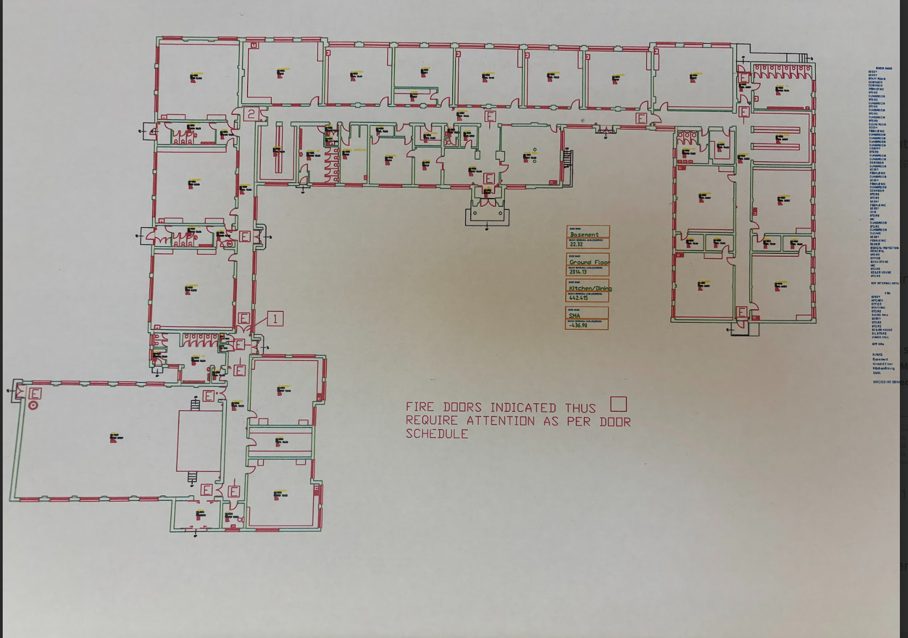
Map of School Fire Exits – Larger image available in school office

