Our Lady and St.Patrick Primary School,
Bunscoil Mhuire agus Phádraig, Downpatrick
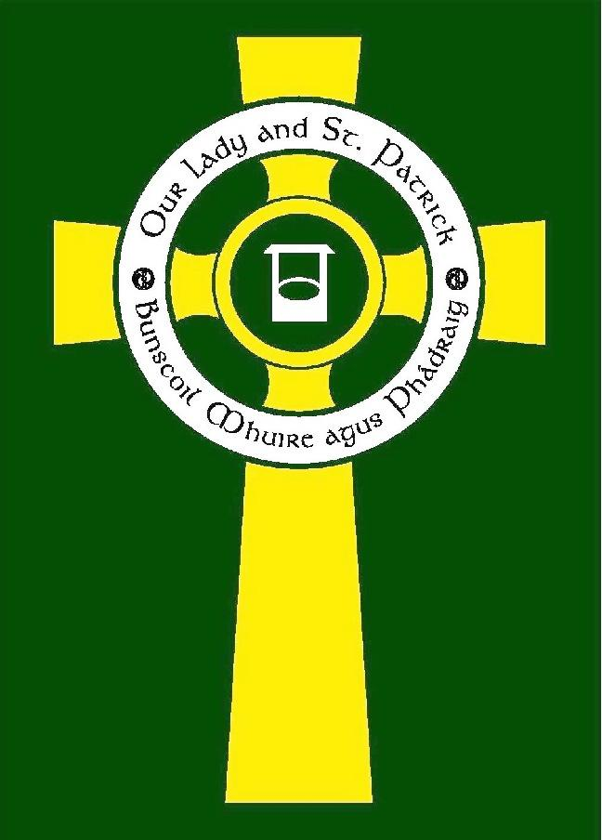

Religious Education Policy
RE Co-ordinator: Philomena Rice

Date of next Review: | May 2027
Signed: (RE Governor)

Signed: (Chairperson Board of Governors)

Dated:

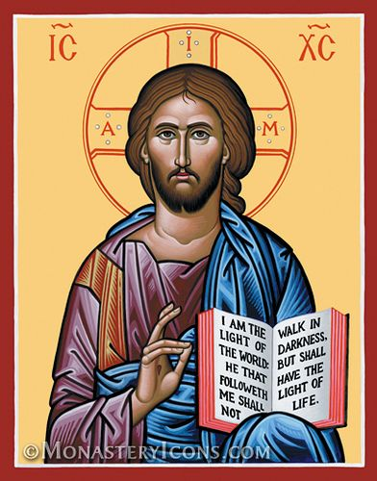

“The task of the teacher and the school is indeed a sacred trust conveyed to them by parents and families. As Catholic educators you have accepted a special responsibility given by parents … On her part the Church looks upon you as co-workers, with an important measure of shared responsibility, in helping to fulfil Christ’s mandate transmitted through the Apostles: "Go therefore and make disciples of all nations … teaching them to observe all that I have commanded you" (Matt 28: 20).

Saint John Paul II, Address to Catholic Educators, 1984

Fully Revised: May 2025

Table of Contents Page No

The Purpose of Teaching Religious Education in the Catholic School 3
Ethos
Mission Statement

Aims and Objectives 4-5

RE Curriculum 5

Marking 6
Assessment and Monitoring
Liturgy and Celebrations
Right to Withdraw

Home/School/Parish/Community Links 6-7

Relationships and Sexuality Education (RSE) 7
Teaching of Special Educational Needs
Staff and Management
The RE Co-ordinator
The Principal
The Board of Governors

Chaplaincy and Liturgy 8
Resources
Outside Agencies
Review of Policy

Appendix 1: Timetabling RE – CCMS Guidance 9

Appendix 2: Time Allocation for teaching RE in Primary Schools 10

Appendix 3: Useful Resources 11

The Purpose of teaching RE in the Catholic School
“An extremely important aspect of your role is that you are called to lead the young to Christ, to inspire them to follow him, to show them his boundless love and concern for them, through the example of your own life. Through you, as through a clear window on a sunny day, students must come to see and know the richness and the joy of a life lived in accordance with his teaching, in response to his challenging demands. To teach means not only to impart what we know, but also to reveal who we are by living what we believe ... This is indeed a vital task of the Catholic teacher: to show Jesus to the young.”

Saint John Paul II, Address to Catholic Educators, 1984

The teaching of Religious Education is at the core of the NI curriculum in a Catholic school as it fulfils its mission to educate the whole person. Religious Education is not only concerned with intellectual knowledge, but its mission is to educate the pupil in discerning the meaning of their existence. Catholic schools, in partnership with the home and the parish, help pupils understand the richness of their faith, and thereby be drawn into a deeper communion with Christ and his Church. Therefore, in Our Lady and St Patrick PS; Bunscoil Mhuire agus Phadraig we believe that Religious Education is the foundation of all our learning and teaching and the entire educational process, and that the teaching and mission of Jesus Christ inspires every aspect of our school life.

Religious Education is compulsory within the Primary School curriculum, and it is recommended that 30 minutes each day is devoted to teaching it. (See Appendices 1 and 2)

In Our Lady and St Patrick PS; Bunscoil Mhuire agus Phadraig we aim to facilitate the fostering of faith, thus ensuring that pupils acquire and develop the essential knowledge and skills to understand their faith, engage in informed discussions, appropriate to their age and understanding, and contribute to society.

The teaching of Religious Education is essentially catechetical thus furnishing the child with knowledge about God and directly encouraging the progressive growth of a relationship with God. Religious Education is linked to all our learning and teaching to enable the children to discover the breadth and depth of God’s Creation.

Ethos
The ethos of the Catholic school represents the very essence of why the school exists. This ethos is firmly rooted in the Gospel message, and being Christ centred, reflects our desire to develop the full potential of every child, staff member and parent within the school faith community. We make every effort to keep it alive in all areas of the curriculum by promoting values of faith, justice, peace and tolerance. Our values and aims are rooted in our school Mission Statement.

Aims

- To provide a Christian environment, where mutual care and love of each other, respect for life and love of God are encouraged and developed.

- To familiarise the children with the Gospel message.

- To enable children of all abilities to develop their full potential in an environment where they know they are loved and can love others.

- To encourage positive self-esteem where each individual can recognise their importance within the school, home and wider parish community and to further develop these links.

- To develop a sense of wonder of the sacred and recognise God’s presence in their lives.

- To actively foster the Catholic faith within the school community through prayer, the Bible, the Sacraments and the example we show to each other.

- To foster the moral development of the children.

- To encourage the development of skills and knowledge that will enable the child to make the right decisions in life and deepen their understanding of what it means to be a committed Christian.

- To recognise, respect and grow in knowledge of other religions and cultures.

- To encourage the children to search, question and examine their own lives in light of what they are learning.

Objectives
Each child is unique and has their own gifts to develop and share with others. We try to further develop these gifts and help the children value each other and their opinions and accept and appreciate that everyone’s opinion is respected. We seek to achieve this by:

- Living the Church’s Liturgical Year through the RE programme: Grow in Love which explores the beliefs, values and way of life within the Catholic tradition.

- Fostering faith through the celebration of the Eucharist, daily prayer, meditations, quiet voice time, prayer services and assemblies.

- Becoming more familiar with and respecting the Bible as the Word of God.

- Preparing the children for the reception of the Sacraments of Reconciliation, Eucharist and Confirmation at the appropriate times and in partnership with home and parish.

- Enhancing doctrinal, moral, spiritual knowledge and understanding through discussion, story, music, art, mime, poetry, journaling, bible search, written work, drama and questions and answers.

- Promoting activities which actively link the school with charities such as Trócaire, the Pontifical Society of Missionary Children, Saint Vincent de Paul (include any other charities of your choice).

- Continuing to develop close links with the local parish, clergy and deacons.

RE Curriculum
The Primary Religious Education programme: Grow in Love supports the implementation of the Catholic Preschool and Primary Religious Education Curriculum for Ireland and the delivery of the Core Syllabus for Religious Education (NI).

Religious Education links with other curricular areas such as Literacy, Art, Music, The World Around Us and ICT. Certain aspects of Personal Development and Mutual Understanding (PDMU) are taught through Religious Education, but from a clearly Christian perspective. Religious Education and PDMU are not the same.

These links are clearly outlined in the monthly Grow in Love planners detailing the liturgical events, Bible passages, learning outcomes and resources to be used.

The curriculum is also significantly enriched by the spiritual life of the school through assemblies, prayer etc. An essential part of the Catholic ethos is the development of prayer. Children are introduced to a variety of different ways to talk to God and so develop their relationship with God:

- Quiet reflection/meditation
- Using their ‘inside voice’
- Praying together
- Composing their own prayers
- Singing
- Learning traditional prayers
- Composing a class prayer

Each classroom has a Prayer Altar area, comprising a cloth in the Liturgical colour, Bible, candle, statue as appropriate, children’s work etc and is added to throughout the month and changed each month.

There is a central Sacred Space area in the foyer/at the front door which is changed with each liturgical season.

Marking
We in Our Lady and St Patrick PS; Bunscoil Mhuire agus Phadraig believe religion cannot always be assessed in the same way as other subjects. Written work will be looked at and marked, adding any necessary comments. We encourage and expect the same high standards in RE as we do for all our curriculum areas. Key words are corrected in pupils’ work if they are spelt incorrectly. Additionally, teachers evaluate and assess the children’s work through discussion, circle time, questioning and observing and participation in discussions, class activities and celebrations, assemblies, liturgies and Masses.

In line with our marking policy, assessment of the children’s work will be positive and in terms of personal growth, emotional understanding and knowledge building will be supportive in encouraging the child in his/her faith journey.

Assessment and Monitoring
The RE Co-ordinator monitors the children’s work (as is the practice in other subjects) and in this way will be able to assess the work being done throughout the school.

Work to be shared at home is sent home once per week. This allows parents/guardians opportunities to chat with their child about the work being undertaken each week and encourages the sharing of Bible stories, prayers and memories.

Children’s work is displayed in the classroom and around the school through a variety of media, often reflecting the themes undertaken in the Grow in Love programme or related to the Liturgical year.

Liturgy and Celebrations
There are important moments in the life of our school community. The celebration of school/class Masses and other liturgies reflect the Liturgical Year and other notable occasions such as the beginning and end of the year, Primary 7 Leavers’ Mass, Enrolment Ceremony, Commitment Ceremony, Service of Light, the celebration of the Sacraments of First Penance (P3), First Holy Communion (P4) and Confirmation (P7) and Catholic Schools’ Week Activities.

Each class is encouraged to prepare and share an Assembly using a theme/topic from the Religion programme. Class assemblies usually last about 10/15 minutes and may contain Bible stories, prayers, prose, poetry, drama, music and singing.

The children have opportunities throughout the school day to pray – at the beginning and end of each day, lunchtime and during RE classes.

RIGHT TO WITHDRAW FROM RELIGIOUS EDUCATION AND COLLECTIVE WORSHIP
Parents have the legal right to withdraw their child from Religious Education (RE) and/or Collective Worship, either wholly or in part. If you wish to exercise this right, please complete the Google Form at the link below. We will then contact you and discuss your preferences and ensure appropriate arrangements are in place. While the school community values the spiritual and educational opportunities provided through RE and Collective Worship, we respect each family’s beliefs and decisions. https://docs.google.com/forms/d/e/1FAIpQLSd8qRqpAmVKjky_30HbEk0C4swKgXdVB1er6KVbVHPDmhf5Fw/viewform?usp=publish-editor (Ctrl + Click to follow link)

Home/School/Parish/Community Links
We recognise we are part of a wider parish community. We take part in parish celebrations, attend parish Masses on a rota basis, provide music, readers and altar servers.

Our parents are invited to join us for many celebrations throughout the school year. We also send Grow in Love activities home once a week to encourage discussion, a sharing of ideas and a time to reflect and pray with your child.

While Religious Education at our school is specifically of the Catholic tradition, we welcome input from other faiths and cultures. We appreciate how the beliefs and values of other faith communities can enrich our experience.

Relationships and Sexuality Education (RSE)
Religious Education can assist with the delivery of Relationships and Sexuality Education. We use: Flourish materials. This is a developmental programme from Primary One to Primary Seven. It is written to present the Christian viewpoint of Relationships and Sexuality Education. It consists of four lessons per class per year and is based on reflective practice as well as parental involvement. Primary 7 children also avail of the Love for Life programme – this is usually delivered on one morning during the school year.

Please see the Relationships and Sexuality Policy document available from the Principal on request/on website.

Teaching of Special Educational Needs
Religious Education in its implementation provides opportunities to assist the faith development of children with special educational needs and is differentiated to meet the needs of all children. The needs of these children can be varied and complex. We recognise the need for resourcing, careful planning and differentiation to cater for children of all abilities ranging from the gifted to those with additional needs. Planning takes account of their strengths and interests. Active participation is encouraged in the learning process.

Staff and Management
The teaching of Religious Education is the responsibility of all staff, and we provide opportunities whereby the staff have the opportunity for In-service through the support of the Down and Connor Catholic Schools' Support Service and sources committed to the Catholic Ethos. This includes the faith formation of staff through retreats or other experiences.

The RE Co-ordinator
The RE Co-ordinator forms a crucial anchor within the area of Religious Education supporting staff, keeping the school up to date on recent developments. The RE Co-ordinator should meet with staff at regular intervals.

The Principal
The Principal in conjunction with the staff implements the Catholic ethos in the school and ensures that RE is taught and well resourced. The Principal is supported in this by the RE Co-ordinator, RE and Ethos Link Governors and close links with the parish.

The Board of Governors
The Board of Governors supports the Catholic ethos of the school and is fully informed about the implications of any curricular review and the impact on Religious Education. Regular updates are provided by the RE Co-ordinator to the Board of Governors.

Chaplaincy and Liturgy
The school chaplain liaises with the school community and supports staff in their faith. Visitation of classes forms an essential part of the ministry as well as involvement in the liturgical life of the school and parish.

Resources
There is an annual requisition for new resources. A list of resources is kept and updated regularly.

All classes have a ‘Sacred Space’, a Children’s Bible, Grow in Love materials.

The Down and Connor Catholic Schools' Support Service provide information about current resources and developments.

Outside Agencies
It is crucial that outside agencies invited into the school agree with the ethos of the school. Any outside agency approached should be asked to sign a document that they agree with the ethos and will work within that context.

Review of Policy
Once ratified by the Board of Governors and thus legally binding, this policy will be reviewed at least every two years. The outcomes from this review will be used to plan training and development needs and to prioritise actions for inclusion in the School Development Plan.

Appendix 1: Timetabling RE – CCMS Guidance

Extract from CCMS document:

CCMS
Council for Catholic Maintained Schools
The Management and Organisation of
Religious Education in the Catholic School

Primary

Boards of Governors should regularly review the school situation with regard to:

Time:

- Is there a specified teaching time allocated to religious education;
- does the allocation of teaching time satisfy the recommended allocation of time;
- is the time allocated utilised to teach the religious education programme;
- is there time for staff to plan, prepare and co-ordinate the relevant programmes within the school;
- is there time for daily prayer and for regular liturgical and sacramental celebrations.

Boards of Governors should ensure that:

- The recommended allocation of teaching time is given to religious education;
- the allocated time is utilised for teaching the religious education programme;
- there is time for daily prayer and for regular liturgical and sacramental celebrations.

Appendix 2: Time Allocation for Teaching RE in Primary Schools

TIME ALLOCATION

Teaching of Religious Education

In the Primary School

LEGAL POSITION OF RELIGIOUS EDUCATION AND TIMETABLING

- The Irish Bishops have stipulated that there should be teaching of RE in primary schools and that this should be a half hour every day for Key Stage 1 and 2; this is confirmed by the Reform Act 1988 … Religious Education will retain its statutory basis in the new revised curriculum.

- Religious Education is compulsory for all pupils, even those under the age of five according to the Education Reform Act of 1988. There is the right of withdrawal under this act thus enabling parent(s) to withdraw their child/children only from Religious Education.

For Information Purposes:

Removal
Because of a clause called ‘Parents Conscience’ a child can be removed from the RE class. For this to take effect parents MUST make a formal request i.e., in writing.

The Problem
In the past a child could have gone to the library for the duration of the RE lesson, but now due to Health & Safety regulations that all pupils must be supervised, it is not always possible to have a teacher assigned this duty. That being the case the child must stay in the classroom.

If, however it is school policy that they MUST DO RE, then the child cannot be removed but this is a fine line to tread and could end up being challenged in Court.

Foundation Stage
Strictly speaking it is thirty minutes daily for all classes, but understandable that foundation stage classes might cope better with shorter sessions.

Appendix 3: Useful Resources

Grow in Love Monthly Planners and Yearly Overviews

https://drive.google.com/drive/folders/1KH2poboDsYOQelwPkXa65p-6cxKZJD2M?usp=drive_link

Prayer Services and Reflections for Staff

https://www.downandconnor.org/prayer-services/

School Charters for FS, KS1, KS2

https://www.downandconnor.org/wp-content/uploads/2021/06/Nursery-FS-Charter-Template-L.docx

https://www.downandconnor.org/wp-content/uploads/2021/06/Nursery-FS-Charter-May-2021-P.docx

https://www.downandconnor.org/wp-content/uploads/2021/06/Key-Stage-1-Charter-Template-L.docx

https://www.downandconnor.org/wp-content/uploads/2021/06/Key-Stage-1-Charter-May-2021-P.docx

https://www.downandconnor.org/wp-content/uploads/2021/06/Key-Stage-2-Charter-May-2021.docx

Sacramental Preparation

https://drive.google.com/drive/folders/17ALn2Vh7RsxWZ7-UHcXdE4ACIgpM-pt0?usp=drive_link

https://drive.google.com/drive/folders/1hUfSnQByNjCrCpDwbxAYA-gAzCVjJuat?usp=drive_link

https://drive.google.com/drive/folders/1nbEybc6imZbKE33x2cyNS8ryzZwK9uPh?usp=drive_link

RSE Guidance and Resources

https://www.downandconnor.org/diocese/education/catholic-education-relationship-sexuality-education/

